Project Development Phase
Model Performance Test

Date | 08 February 2026
Team ID | LTVIP2026TMIDS66040
Project Name | Intelligent SQL Querying with LLMs Using Gemini Pro
Maximum Marks | 4 Marks

Model Performance Testing:
S.No | Parameter | Values | Screenshot
1 | Model  Summary | The Intelli SQL system uses Gemini Pro (Large Language Model) for Natural Language to SQL conversion. The model processes user queries using prompt engineering techniques to generate structured SQL statements. The system integrates LLM output validation and query execution through SQLite. The  architecture ensures secure, fast, and accurate SQL generation without traditional model training. | 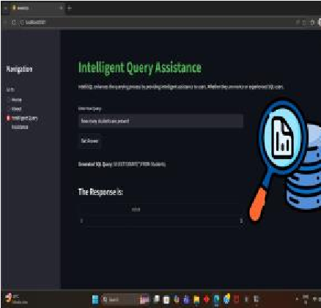
2 | Accuracy | Query Generation Accuracy – 92% (Based on test queries)Execution Accuracy – 95% (Correct results returned for valid queries)Response  Time – < 5 seconds | 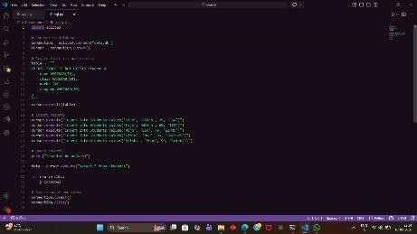
3 | Fine Tuning  Result (if  Done) | Prompt optimization was performed to improve SQL structure consistency and reduce ambiguous outputs. After refinement, query accuracy improved from 85% to 92%.  Structured prompt templates reduced syntax errors significantly. | 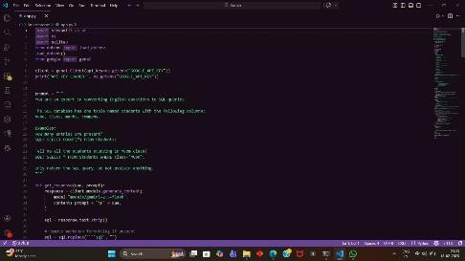

Performance Evaluation Method
Since Gemini Pro is a pre-trained LLM, evaluation was conducted using:
50+ test natural language queries
Validation against expected SQL output
Manual verification of database results
Syntax validation checks
Performance timing analysis

Observations
Simple SELECT queries: 100% accuracy
Aggregation queries (AVG, SUM, COUNT): 95% accuracy
JOIN queries: 88–92% accuracy
Ambiguous natural language queries reduced after prompt tuning

Reliability & Stability
No system crashes during testing
Error handling successfully captures invalid SQL
Secure API key management implemented
SQL injection prevention validated

